All photos in high resolution quality can be found on the USB stick attached to the press kit. If you have any questions, please contact Nadia Gondolph-Möllmann, Corporate Communications Manager at nora systems GmbH (phone: +49 (0) 6201 80 5676; e-mail: presse@nora.com) or Nora Lippelt, Hering Schuppener Unternehmensberatung für Kommunikation GmbH (phone: +49 (0)211-430 79 281; e-mail: nlippelt@heringschuppener.com).

- New colours and new design for the nora bestseller
New look for noraplan signa rubber floor covering

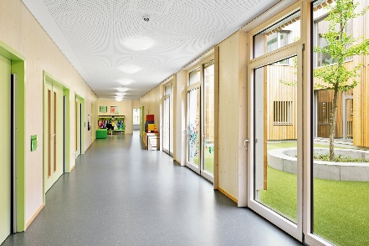 | 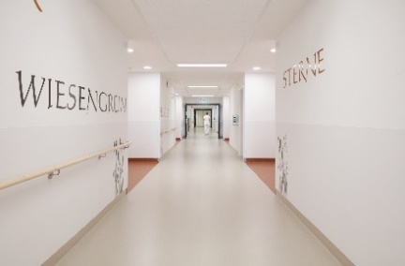 | 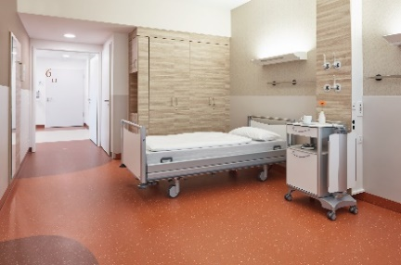
nora systems_Bewegungskindertagesstätte Mobile_Sachsenheim_1  Copyright: RALF DIETER BISCHOFF | nora systems_Krankenhaus Heppenheim_1  Copyright: @samba photography_Markus Bachmann | nora systems_Krankenhaus Heppenheim_2  Copyright: @samba photography_Markus Bachmann
 |  | 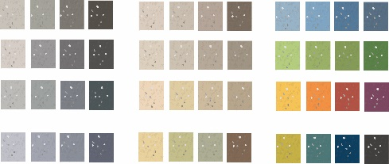
nora systems_noraplan signa_Collage  Architektur  Copyright: @nora systems GmbH | nora systems_noraplan signa_Collage  Bildungswesen  Copyright: @nora systems GmbH | nora systems_noraplan signa_Farben  Copyright: @nora systems GmbH

- nora systems shows its many facets in the "House of Design"
Customer-specific solutions and design classics as a recipe for success

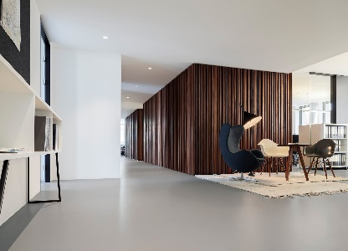 |  | 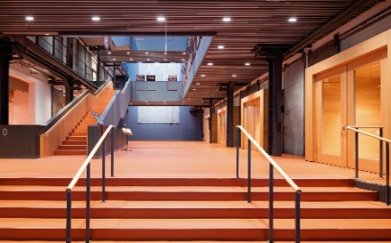 |  | 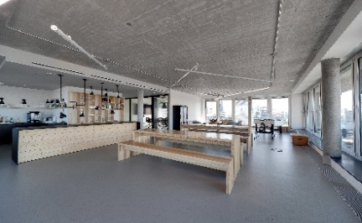
nora systems _Architekturbüro blocher partners_Mannheim  Copyright: Daniel Vieser. Architekturfotografie, Karlsruhe |  | nora systems_Barenboim Akademie_Berlin_1  Copyright: www.wilhelmy-fotografie.de; Dirk Wilhelmy |  | nora systems_Bürohaus BOA Vista_Hamburg  Copyright: Dominik Münich, Grasbrunn / München
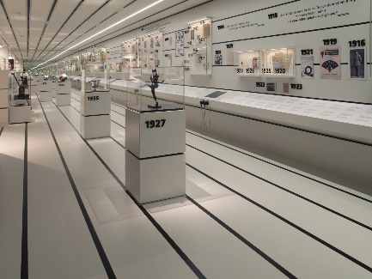 |  | 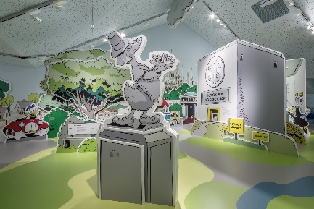 |  | 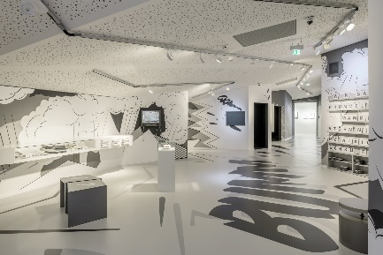
nora systems_Deutsches Fußballmuseum_Dortmund  Copyright: nora systems GmbH |  | nora systems_Erika-Fuchs Haus_Schwarzenbach a.d. Saale_1  Copyright: nora systems GmbH |  | nora systems_Erika-Fuchs-Haus_Schwarzenbach a.d. Saale_2  Copyright: nora systems GmbH
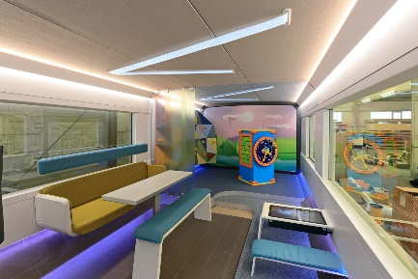 |  | 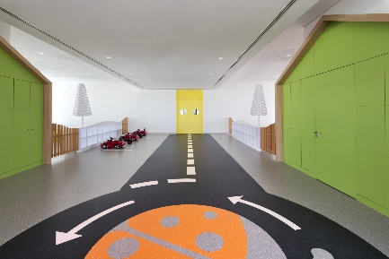 |  | 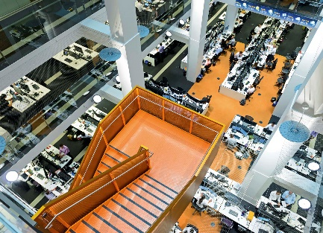
nora systems_Ideenzug_Deutsche Bahn  Copyright: Deutsche Bahn AG |  | nora systems_Ladybird Early Learning Centre_Dubai  Copyright: Gerry O’ Leary |  | nora systems_Macquarie Bank Sydney_1  Copyright: Jesse Taylor Photography
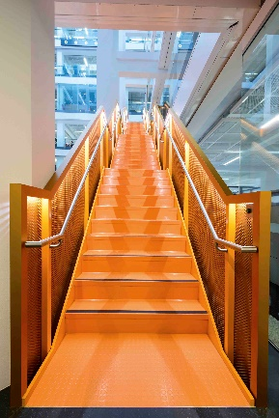 |  | 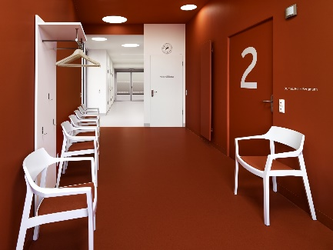 |  | 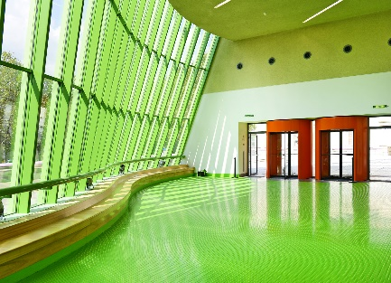
nora systems_Macquarie Bank Sydney_2  Copyright: Riddle Stagg |  | nora systems_Medicum_Altenburg  Copyright: @Oliver Heinemann |  | nora systems_Staatsgalerie Stuttgart  Copyright: Volker Naumann Fotografie
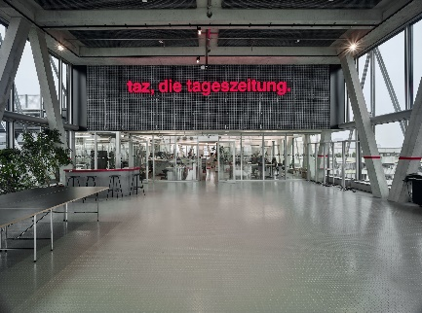 | 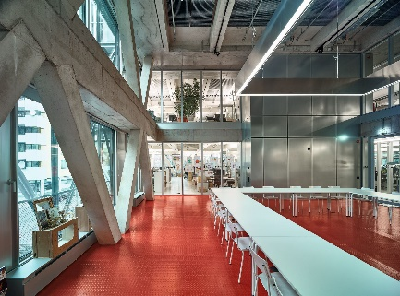 |  | 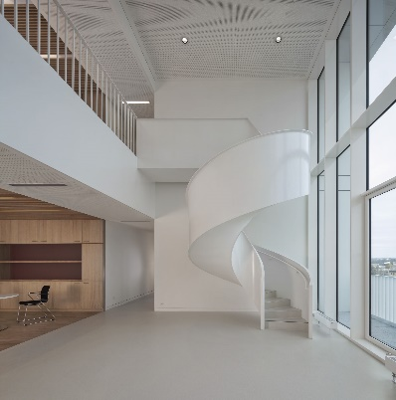
nora systems_taz Neubau_Berlin_1  Copyright: Stephan Falk, BAUBILD | nora systems_taz Neubau_Berlin_2  Copyright: Stephan Falk, BAUBILD |  | nora systems_TU MAIN Chemnitz  Copyright: Werner Huthmacher, Berlin
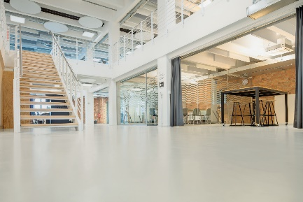 | 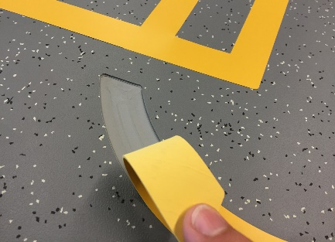
nora systems_Zalando_Berlin  Copyright: www.wilhelmy-fotografie.de | nora_systems_gefräste_Intarsie  Copyright: @nora systems GmbH

- Systemised flooring
From hospitals to kindergartens: noraplan signa is an all-rounder for every field of application.

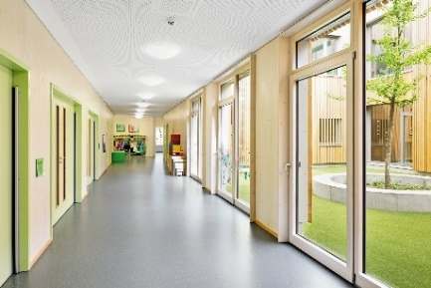 | 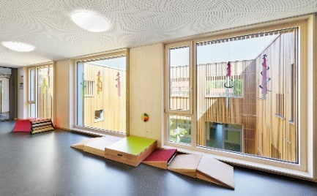 | 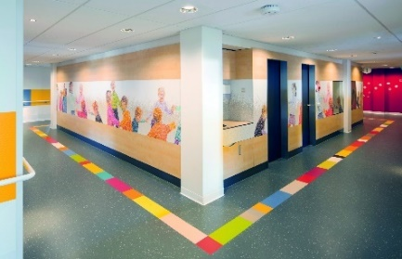
nora systems_Bewegungskindertages-stätte Mobile_Sachsenheim_1  Copyright: RALF DIETER BISCHOFF | nora systems_Bewegungskindertagesstätte Mobile_Sachsenheim_3  Copyright: RALF DIETER BISCHOFF | nora systems_Bronovo Krankenhaus_Den Haag_1  Copyright: Studio Csany / Imre Csany
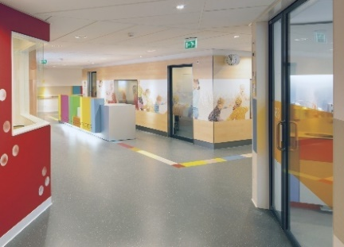 | 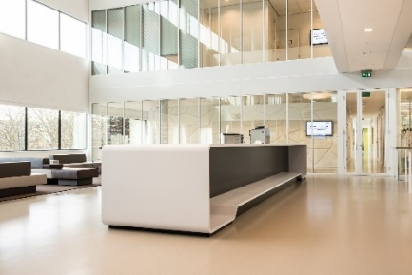 | 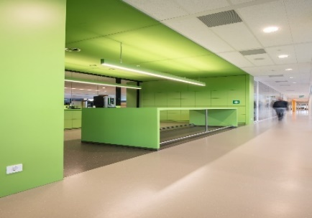
nora systems_Bronovo Krankenhaus_  Den Haag_2  Copyright: Studio Csany / Imre Csany | nora systems_Danone Innovation Centre_Utrecht_1  Copyright: CR-BEELDWERKEN | nora systems_Danone Innovation Centre_Utrecht_2  Copyright: CR-BEELDWERKEN
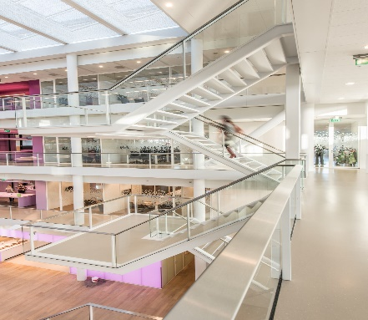 | 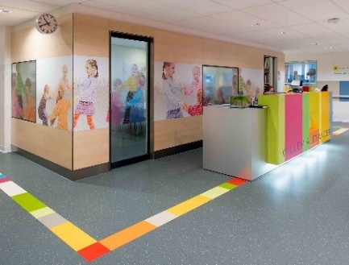
nora systems_Danone Innovation Centre_Utrecht_3  Copyright: CR-BEELDWERKEN | nora systems_Krankenhaus Bronovo_Den Haag_NL  Copyright: Studio Csany / Imre Csany
- Fact Sheet
Nora systems GmbH: Data and facts

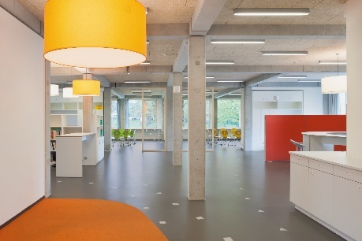 | 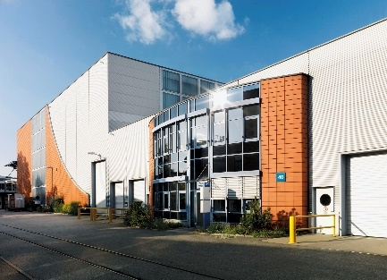 | 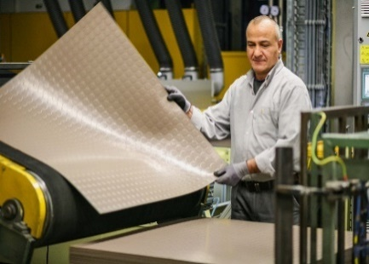
nora systems_Berufliche Schule Hamburg-Eidelstedt_1  Copyright: Frank Aussieker | nora systems_Headquater Weinheim A  Copyright: Oliver Heinemann | nora systems_Produktion  Copyright: @nora systems GmbH

- The rubber specialist
Competence in sustainability and design – nora rubber floor coverings

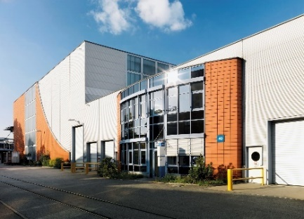 | 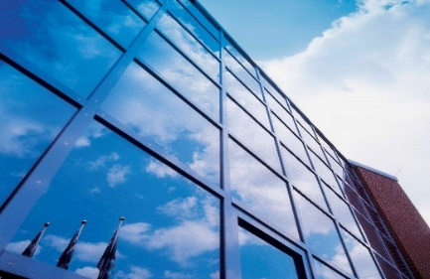 | 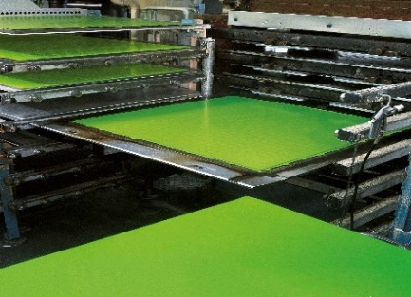
nora systems_Headquater Weinheim A  Copyright: Oliver Heinemann | nora systems_Headquater Weinheim B  Copyright: nora systems GmbH | nora systems_norament Fliesen  Copyright: nora systems GmbH
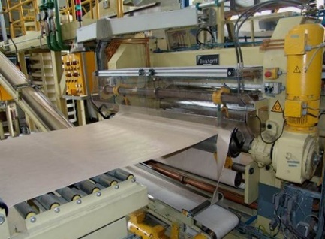 | 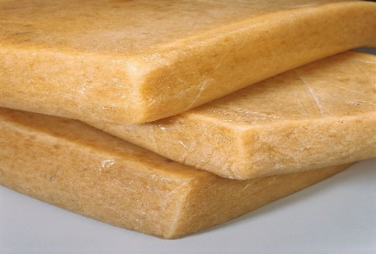
nora systems_noraplan Bahnen  Copyright: nora systems GmbH | nora systems_Rohstoff Kautschuk  Copyright: nora systems GmbH

Copyrights photos:
The copyrights are noted in the image properties. Please name the photographer for publications.

