# nora systems GmbH: Data and facts

The nora systems GmbH produces and markets high-quality rubber floor coverings and floor covering systems, steptreads and shoe components under the nora® brand. The company has its headquarters in the German town of Weinheim and was formed from Freudenberg Bausysteme KG in 2007. As a global market leader, it has shaped the development of rubber floor coverings for many years and proudly uses the label “Made-in-Germany”. In 2018, nora systems was acquired by Interface Inc. based in Atlanta (USA). Interface is the largest manufacturer of modular carpet tiles for the commercial sector in the world.

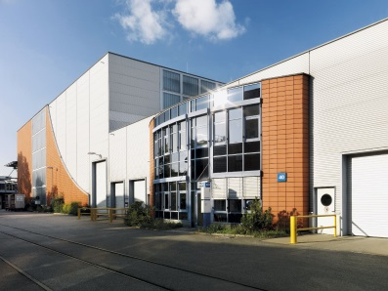**Key performance indicators**

* Sales in 2017: € 229.1 million
* Employees: more than 1000 worldwide, around 75 % of whom are in Germany
* Core market segments: Healthcare, education, industry   
  Public sector construction, transport sector

**Products**

* Product lines norament® and noraplan® in over 300 standard colours   
  Diverse designs and individual custom products
* Tailor-made steptreads
* Comprehensive range of accessories and system solutions

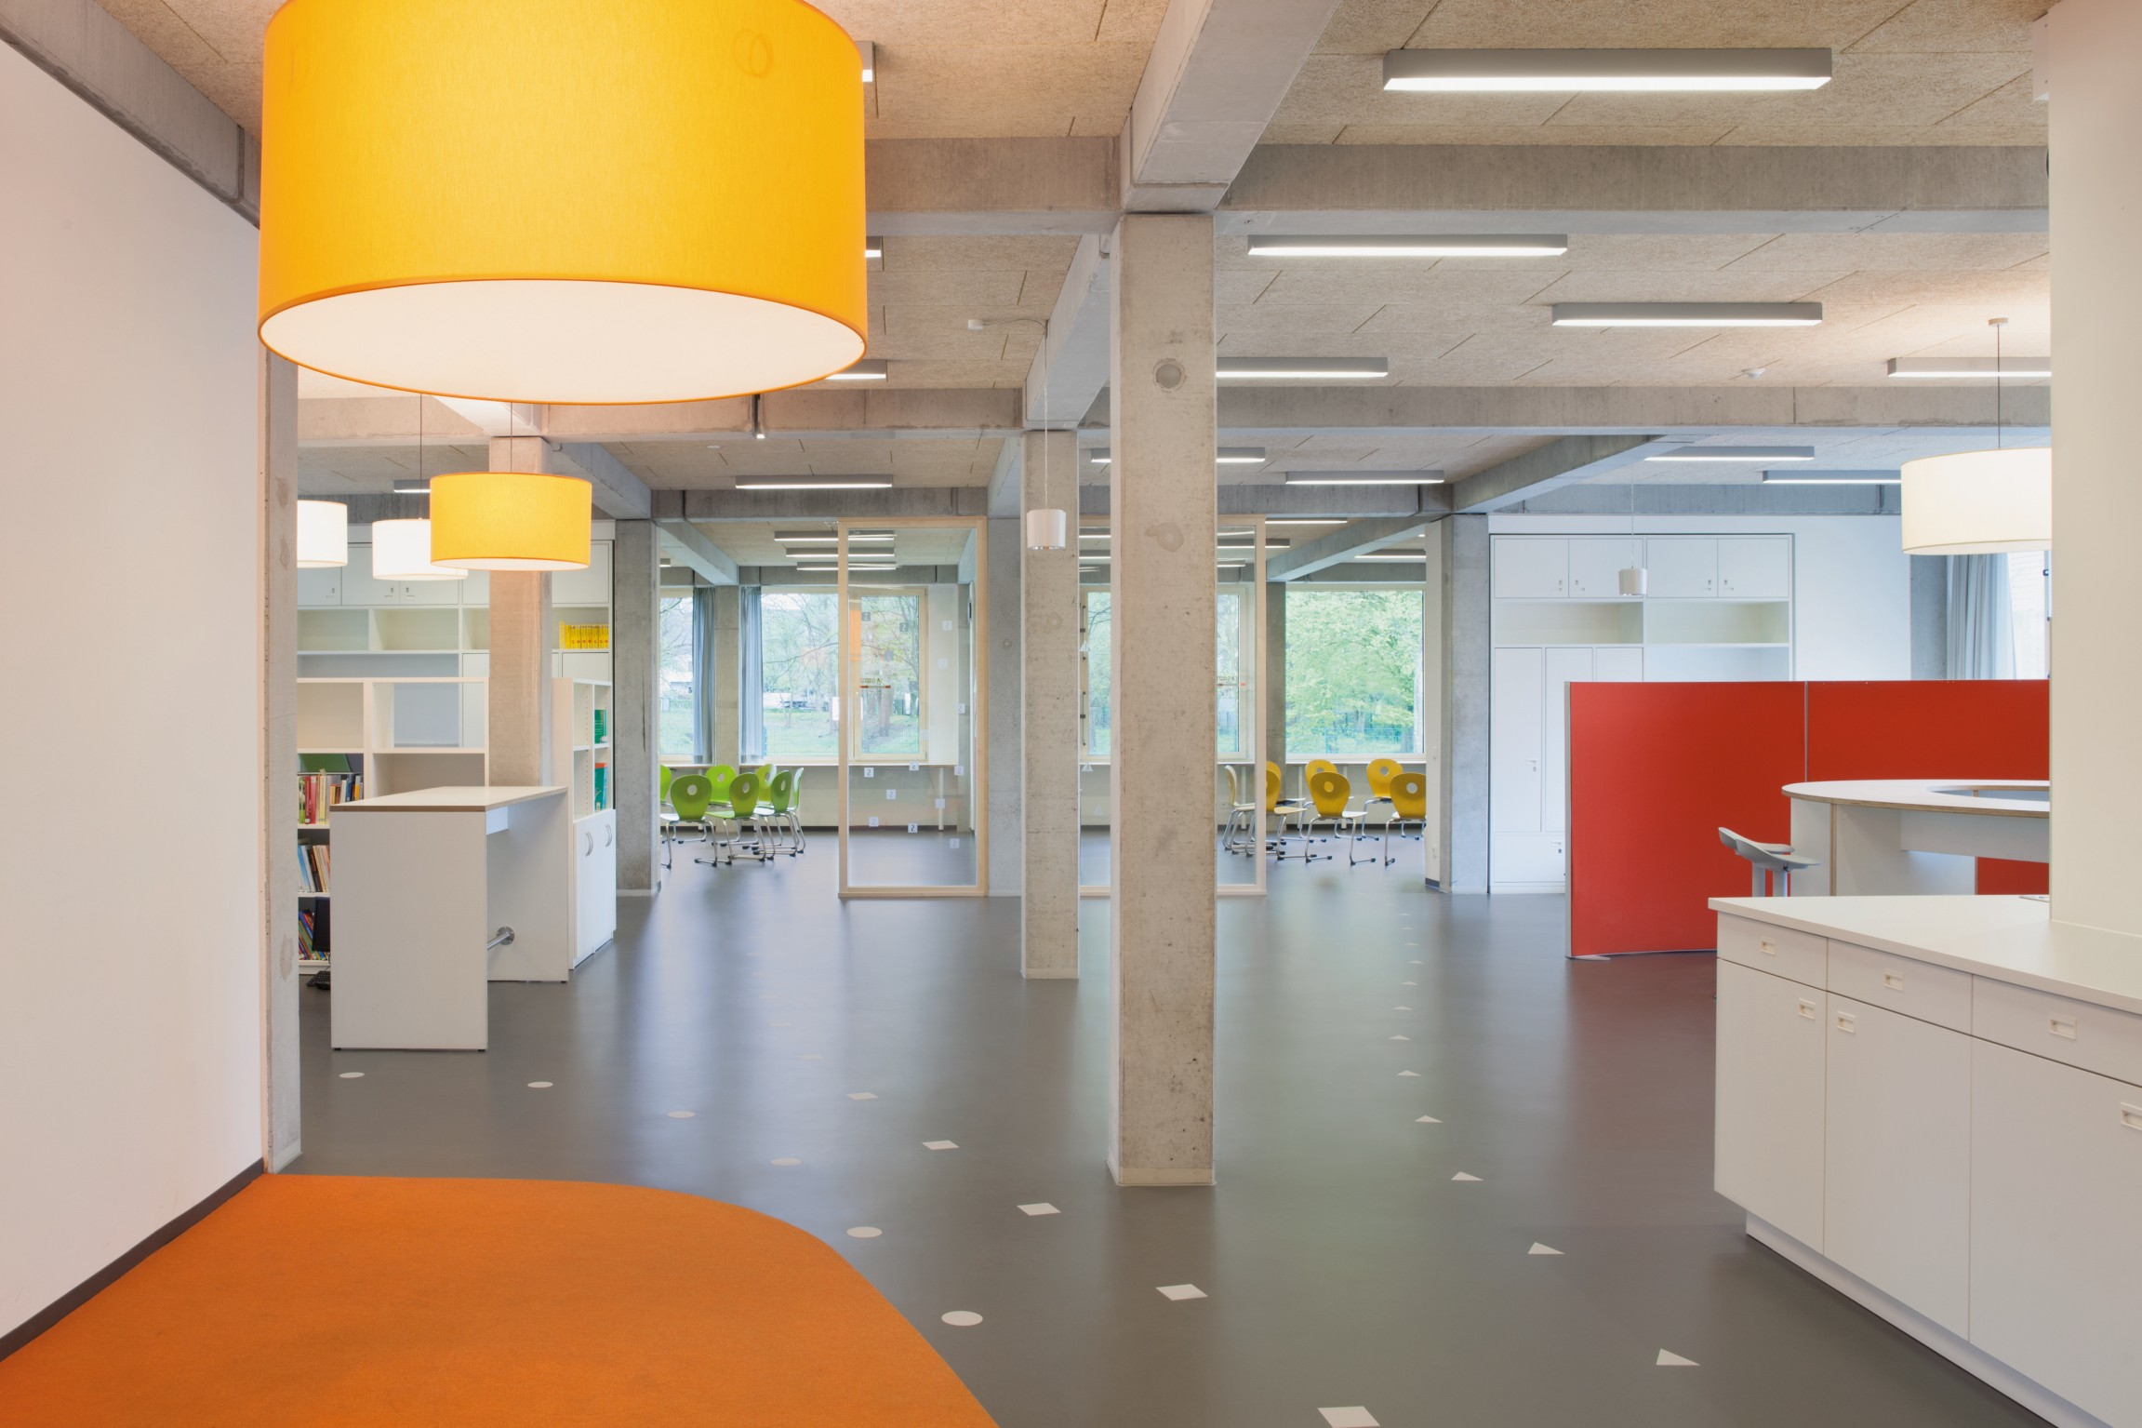**Applications**

* Hospitals, retirement homes and care homes
* Schools, universities, nursery schools
* Production facilities in various branches of industry
* Public buildings and public institutions
* Passenger trains, ships, buses and trams

# nora systems GmbH: Data and facts

The headquarters are located in Weinheim, Baden-Wuerttemberg, Germany. The facility functions as the development site, production site and administrative headquarters.

nora systems holds 15 branches around the world, including in the USA, Chile, China, Dubai, Russia, England, France, Austria and Switzerland. nora delivers to more than 80 countries across the globe.

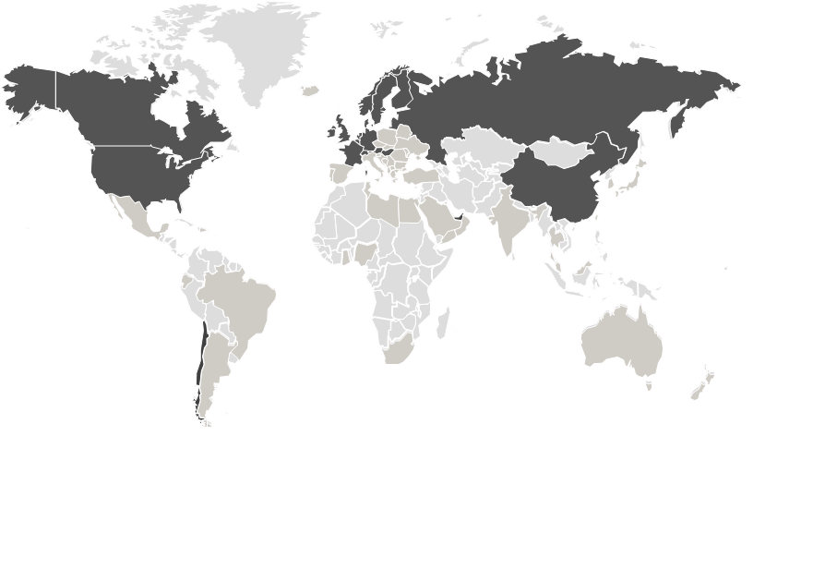

**C:\Users\bschschu\Desktop\Bild1.pngC:\Users\bschschu\Desktop\Bild2.png**

**History and current developments**

|  |  |
| --- | --- |
| 1938 The nora systems success story begins with the production of  shoe soles.1950 Start of production of nora® rubber floor coverings.1967 The norament® pastille enters the architecture market.  Frankfurt airport helps this floor covering to make a breakthrough.1975 Sir Norman Foster adds a splash of colour. A bright green  shade is added to the range. **From 1980** Green light for international expansion.  nora systems is soon represented by branches or  export partners in around 80 countries. From 1990 The last decade of the 20th century stands for design diversity and customer orientation. With architect workshops and installer trainings, nora systems offers comprehensive service. **From 1996** nora systems gives higher priority to sustainability.  nora rubber floor coverings are awarded numerous  environmental compatibility certificates.  **2007** nora systems GmbH is formed from Freudenberg  Bausysteme KG. | **2010** nora system blue® makes the company the sole provider of floor covering systems awarded the Blue Angel eco label for low emissions.  **2012** noraplan® unita, introduced in 2011, is awarded the red dot design award due to its innovative material combination of rubber and granite chips.  **2012 - 2015** Successful new versions of both product lines: noraplan® sentica, norament® satura and noraplan® valua  **2015** nora nTx® is launched on the market: Forward-thinking and innovative laying technology for rubber floors that reduces fitting times by up to half and lowers costs.  **2017**  New products noraplan® lona and norament® arago are presented at the BAU trade fair in Munich in January.  **2018**  nora systems GmbH is acquired by Interface Inc., Atlanta (USA). Interface is the largest manufacturer of modular carpet tiles for the commercial sector in the world. The nora® brand name for rubber floor coverings is retained.  nora systems launches nora one, a safe installation system with exended warranty, on the global market. |